**DESIGN OF MULTI WAVELENGTH OPTICAL POWER METER WITH RASPBERRY PI**

Muhammad Syafiq1*, Dwi Hanto2

[1] Sepuluh Nopember Institute of Technology

[2] Physics Research Center, Indonesian Institute of Sciences

*Email: syafiqguitarist@gmail.com

**Abstract**

This paper describes the design of Optical Power Meter (OPM) with the Raspberry Pi. The research was conducted on the design of signal conditioning circuit and data processing system with the Raspberry Pi. This study uses 6 units of resistance which is 100Ω, 1kΩ, 10kΩ, 100kΩ, 1MΩ and 10MΩ. Resistors are used to expand the measurement range of power and have been adjusted to the desired measurement range that is 5 dBm to -50dBm. The light source used in the form of laser with a wavelength of 1310nm and Tunable laser with a wavelength of 1552nm. For the variation of the optical output power, we used Attenuator with attenuation limit to 40dBm. From the measurement results, the data obtained compared with OPM Anritsu ML9002A as validation and calibration settings. The results obtained from reading light power by RPI OPM and OPM Anritsu shows that the value is almost equal with maximal difference value between them is 0.52 dBm at wavelength 1310nm with 36 dBm attenuation and minimal difference value that is 0.01 dBm at wavelength 1310nm with 32 dBm attenution.and the average different is 0.15 dBm.

Keywords : Optical power meter, signal conditioning, data processing.

**1. Introduction**

Light is an important element in fiber optic communication systems. The use of this light covers all aspects of the characteristics of light. In the communication system, the power aspect is something that must be considered. Optical Power Meter is a tool used to measure the power of the transmitted light. Although there has been a lot of OPM application in terms of both measurements and scope of use, need for OPM and development are still widely. The cause is the start of technological developments in the use of light as a tool for human activities. The need to communicate is a key priority in the utilization of light because light itself can be spread with the speed of 3x108 meters per second. Such speed is what is needed in the communication system. For long-distance communication systems, power light is important. When light propagates, there will be loss of power caused by the effects of light scattering and absorption of fiber optics. So the calculation is necessary so that the transmitted data can be received perfectly. OPM is needed for power measurement of the light. Components of the most fundamental and important in the OPM is a sensor. The more sensitive the sensor will increase measurement range, precision, accuracy of the tool. Surely the sensor itself has a range of work which is

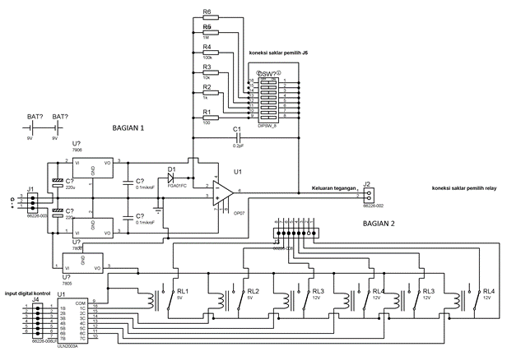

Figure 1. TransImpedance Circuit

influenced by the type of material of the sensor itself.

Raspberry Pi is a SBC (Single Board Circuit) type of microprocessor most recently released by the Raspberry Pi Foundation in 2012 ago. Certainly, it has many applications such as data processor. The Most use of the Raspberry Pi, that is in the field of network control. Because the base architecture of the Raspberry Pi itself is not much different from the Arduino and other microcontroller. Only the broader features that distinguish Raspberry Pi with other microcontroller. Because the products are still new, Raspberry Pi is in research of its potential in all purposes either in industry or home personal. Therefore the use of Raspberry Pi as OPM can be said is new.

Raspberry Pi itself does not have ADC component, so it needs an external ADC as an analog signal conversion before entering the Raspberry Pi. For the present study, we used the MCP3204 ADC IC from microelectronic completed with MCP6284 as input gain Op-Amp. MCP3204 has a 12-bit resolution so that the measurement range will wider. As for sensors, we used FGA 01FC InGaAs Photodiode from Thorlabs. This photodiode has a spectral response characteristic in the wavelength range 800nm - 1700nm.

In this paper, we will explain how the process of designing an Optical Power Meter with the components described above, along with programming and circuit components. Validation of the tool is done by comparing the measurement results of OPM RPI with the measurement results using Handy Optical Power Meter Anritsu ML9002A.

**2. Methods**

In this study, we used Op-Amp with Transimpedance types. The circuit can be seen in Figure 1 part 1. This circuit is useful for conditioning the incoming signal through the 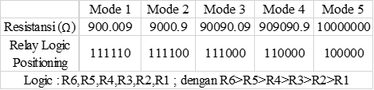 Figure 2. Mode and its resistance value

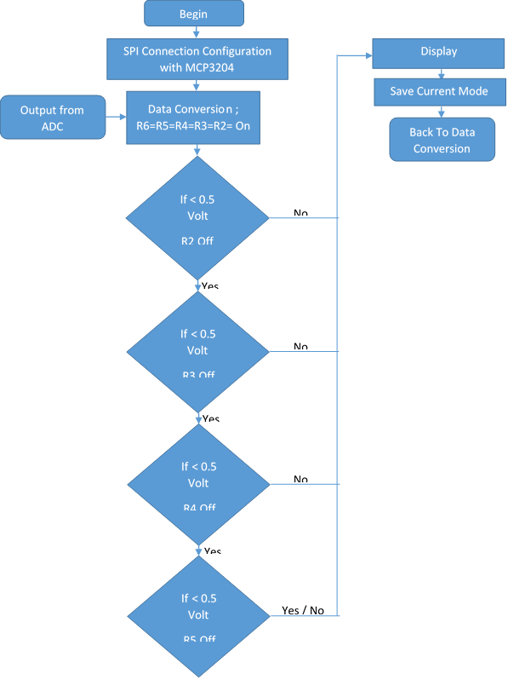photodiode and transform it in the form of voltage. In this series, the components used are FGA 01FC InGaAs photodiode as light sensor, IC OP07CP as Op-Amp, Regulator +- 6V LM(78/79)06, Capacitor Elco 220 µF, (100Ω, 1k Ω, 10k Ω, 100k Ω, 1M Ω, 10M Ω) resistor, Relay 5V, and 9V battery as Power Supply.

In Figure 1 Section 2 is a switching circuit which consists of 6 components and ICs Relay ULN2003A as drift current supply to the relay. Resistor mounted parallel to each other on the output connected to switch. This tool has a default state that all resistors are connected so that the total resistance value is 900.009 Ω. Mode change is done when photodiode sensor undergo saturation so that it has a maximum voltage of 5 volts and when the voltage on the photodiode is below 0.5V. When the photodiode experiencing saturation, mode change is done by turning off most small resistor and this is done until the photodiode is not in saturation and resistors connected is only 10M Ω which is the highest total resistance value. Its process flow can be seen in Figure 3.

For the signal processing and control, the output of the Transimpedance circuit is used as an input of IC MCP3204 ADC that converts the analog signal into a digital signal that will be sent to the raspberry pi for data processing as shown in Figure 4. Before getting into the raspberry pi, the signal from the ADC should be lowered beforehand because raspberry pi has a Logic High 3.3.V maximum and minimum 0.3V logic high while the ADC has a maximum of 5V. Raspberry pi can not accept a voltage higher than 3.3V because it will cause a burning raspberry pi.

Figure 3. Flow Chart Data Processing

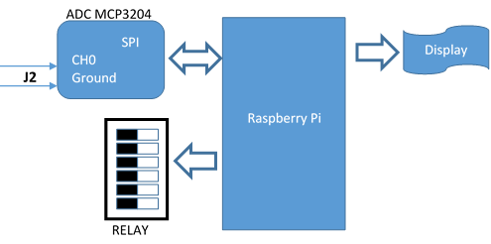Figure 4. Connection System with Raspberry Pi

The data that has been entered then recorded and then compared with the data obtained from the use of OPM Anritsu ML9002A as data validation and calibration tools.

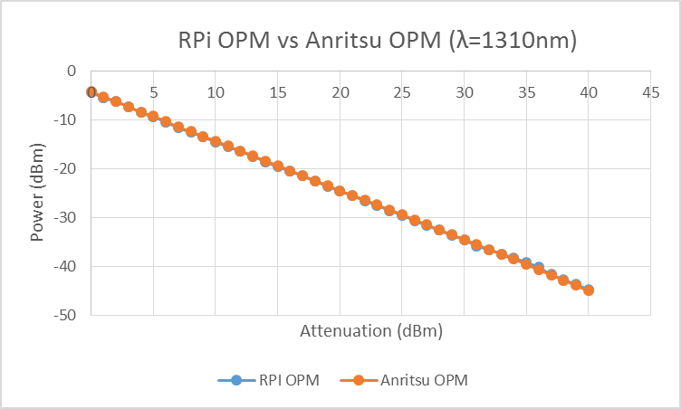

Gambar 5. Hasil Pembacaan RPi OPM dan Anritsu OPM pada panjang gelombang 1310nm

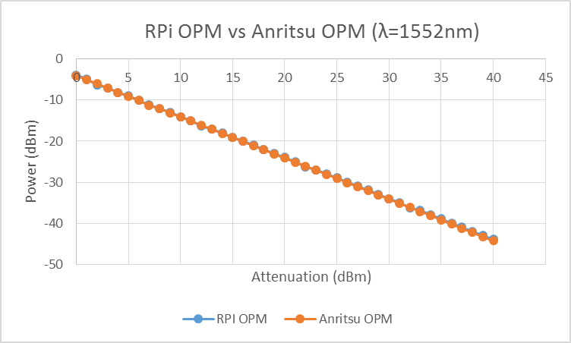

Gambar 6. Hasil Pembacaan RPi OPM dan Anritsu OPM pada panjang gelombang 1552nm

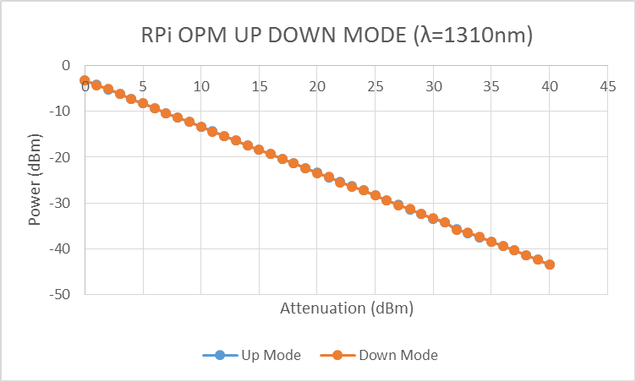

Figure 6. RPi OPM with Up and Down Mode Measurement

**3. Results and Discussion**

At the time of the laser do not experience attenuation or attenuator is 0, the power readings in the RPI OPM has value -4.4 dBm and at Anritsu ML9002A OPM has value -4.28 dBm. This value is the value of the laser power. Furthermore, for each increment value of attenuator, power readings at OPM also increase with the addition of a given attenuation.

In the laser with a wavelength of 1310nm difference between the RPI readings with Anritsu OPM OPM has maximum difference value of at 0.53 dBm and minimum value 0.01 dBm with an average difference value 0.15 dBm. As for the laser with a wavelength of 1552nm difference between the RPI readings with Anritsu OPM OPM has maximum difference value of at 0.41 dBm and minimum value 0.03 dBm with an average difference value 0.155 dBm. The most substantial difference readings in when RPi OPM is in mode 5. This is because in mode 5, change in the bandwidth is not comparable with other modes. The advantage of the mode change itself is that we can increase the bandwidth of photodiode sensor so that even small power input can still be detected. The graph in Figure 5 shows the power readings from the RPI and Anritsu OPM OPM are almost equal.

RPi OPM can also measured data from reversed input which is from lower input to higher. So the attenuator is set from higher attenuation to lower attenuation. The graph in figure 6, show that power read from lower to higher input are same as power read from higher to lower input.

**4. Conclusion**

RPI OPM with the components mentioned above were able to measure the power of the incoming light with a range of -50 dBm to 4.96 dBm. Comparison of the data obtained showed that the reading of the RPI with Anritsu OPM OPM is almost the same. Functionally, the difference is negligible, because Anritsu OPM has a level of measurement accuracy of 5% (-10 dBm, CW mode). With this comparison it can be concluded that the data obtained from RPi OPM are valid. To improve the reading range, the resistor can be changed for the future in such a way to adjust the reading of the desired range.